# Classes offered at Pima

Pima offers a variety of programming focused courses that are both inside and out of the core programmer/analyst degree track. Many of these set you up with the foundational skills needed to continue your education or to start finding entry level positions that will continue training you in their preferred workflows and tools.

## CIS 129/131 Programming & Problem Solving I/II

This is the core intro programming course. It includes a base overview of computer systems/components as well as an introduction to how languages are interpreted and/or compiled (meaning how does the computer go from our written code to instructions that are understood by the computer).

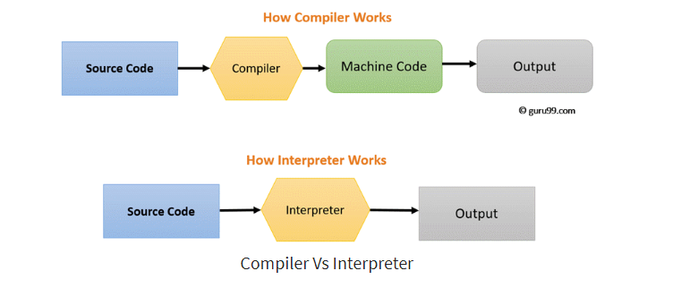

Both of these courses are taught in Python, a robust interpreted programming language that’s used by everything from software development to data science, machine learning and AI. Our bootcamp/workshop this week is focused on learning the building blocks of python so you’re ready to tackle the courses. We’ll be going over data types, variables, loops, functions, and touching on object oriented programming. All of these are introduced and practiced in these two courses.

The key to being successful in your programming courses are to learn how to think computationally, meaning in a specific sequence. It’s a tall ask to shape your thinking while learning a new programming language but the core skills you should develop are how to program and less on the specific language. You’ll find as you take your next programming courses that use Java, C++ or Assembly much of the skills will transfer and you’ll often just be googling the syntax of how to write that code’s language.

## CIS 188 Scripting for Automation

It’s recommended you take this after knowing enough base python and have an understanding of breaking up tasks into computational steps to write the instructions in code. There is an intro to python but it ramps up quickly. This course is also in python but focuses on applicable uses of programming skills (batch renaming files, regular expressions, spread sheets and files, etc.)

You can actually read this course’s textbook for free online and practice the projects ahead of time. <https://automatetheboringstuff.com/>

It’s a fun and challenging course that offers you a look on solving problems after you developed your foundational programming skills.

## CIS 250 Intro to Assembly Language

Assembly is your first introduction to a “low-level” programming language. The code communicates with the hardware after being turned into machine language through an assembler. Often in your other languages they get “compiled” into machine code which then executes the program.

With Assembly you’re learning about number systems, the actual machine architecture, working with a stack data structure, array processing/indexing/sorting.

This course is great for someone looking to transfer into the Computer Science or Computer Engineering fields at UA.

## CIS 265 The C Programming Language

The C language is a lower-level programming language that only allows procedural (meaning no object oriented programming) style of programming. It also has no way to automatically manage memory when creating data structures in your code.

This course goes over various programming scopes, using multi-dimensional arrays and the concept of pointers and structs (which are tools to point to a location in memory within a computer).

## CIS 269 Data Structures

This is your most important programming course if you plan to continue on into computer science, engineering or software development. Data structures are one of the two keys to solving all programming problems. The other being algorithms.

Structures hold the data, algorithms provide the instructions to manipulate the data. Within the computer science degree at UArizona, the data structures and algorithms course is known as a “weed out” course; taking this course before will give you that foundational understanding to tackle the trickier courses you’ll expect as a transfer student.

This course goes over a variety of data structures within the C++ language, as well as standard algorithms you’ll be repeatedly using; including sorting and searching.

## CIS 278 C++ & Object Oriented Programming

This is the pre-req to taking 269 - Data Structures. It provides an overview of the syntax of the C++ language. Also requiring 131, you’ll have the foundational knowledge to apply computational thinking to problems and mostly be focusing on using the C++ syntax. It also goes over more advanced concepts like pointers to access specific data in memory, typing your data, OOP concepts of polymorphism and inheritance, and standard libraries in C++.

## CIS 279 Java Programming

This is your introduction to the Java programming language. It includes a base overview of the syntax of the language but relies on your previous knowledge of computational thinking learned in 131. You’ll also be using different Java specific IDE called Eclipes, and tools to build specific applications through Maven.

]